**FEIGN CLIENT**

Feign client is a method of making call to the other apis.

1.Add the feign dependency

<dependency>

<groupId>org.springframework.cloud</groupId>

<artifactId>spring-cloud-starter-feign</artifactId>

<version>1.4.7.RELEASE</version>

</dependency>

2.now add @enablefeignclient dependency in the controller to let it look for some feign clients

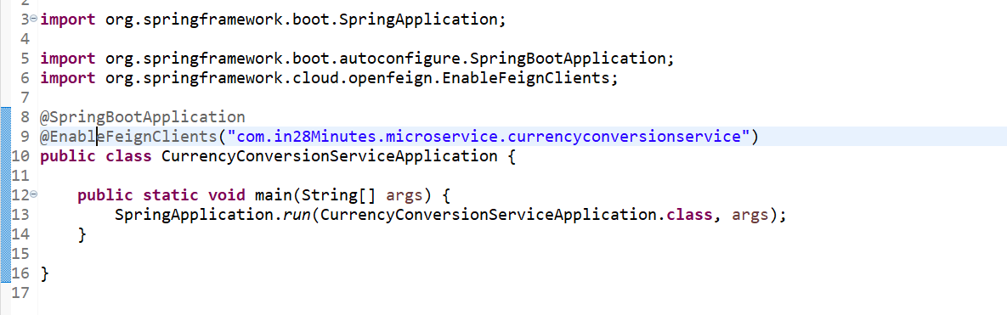

3.Now make an interface where in we have to declare the method name same as he one for which we are claing in the other service.

4.now from controller make a call to this method.(the url specified must be same as is required to call the service you can give any name to the method.